Group 3

04/25/22

INFO320

**CarMax Report**

Josh Sandoval led our group and created several different PivotTables in Excel to demonstrate the relationships between NPS types and the experiences of CarMax customers. Of several observations she made, three stood out to us the most. Firstly, we found that customers that had more appointments had lower NPS scores and were more likely to be in the “Detractor” category. In addition to this, we found that NPS scores tend to increase after a few test drives, but we see less promoters when the number of test drives is more than 8. We took note of a few stores that had excellent NPS scores, and a few that had very low scores as well.

Based on the observations our team made, several reasons could be behind why lower scores are reported. Customers who have made more appointments at Carmax tend to have lower NPS scores, potentially indicating that they are having a hard time finding the right vehicle. Our second observation came from while customers were in store; NPS scores tend to see a drop around eight test drives. If a customer is taking a considerable amount of time to find their perfect vehicle, and fails to find one after eight test drives, they may be feeling frustrated. Finally, in our last observation we noticed that Stores 5694, 4592, and 4341 have excellent NPS scores, while Stores 1592 and 9694 have very poor NPS scores. This made us wonder, what are the former stores doing better than the latter stores? While stores 4592 and 4341 had high scores but very little data, store 5694 stood out against the rest. In our Knime workflows, created by Mia and Carla, showed that the variables of location, count of appointments, count of test drives, and staffing level gave us an accuracy score of 80.75% using logistic regression.

To remedy the test driving issue, we should thoroughly analyze what each customer likes and dislikes about each vehicle they test drive in order to pair them with the right vehicle. In addition to helping them find the right vehicle, it also creates a more personalized experience and connection with the customer. This goes hand in hand with the number of appointments a customer has. The goal is to make sure the customer is satisfied in the least amount of visits possible. We can consider booking less appointments in a day and increasing how long each customer’s appointment lasts. Josh and Carla created Tableau visualizations to help emphasize these points.

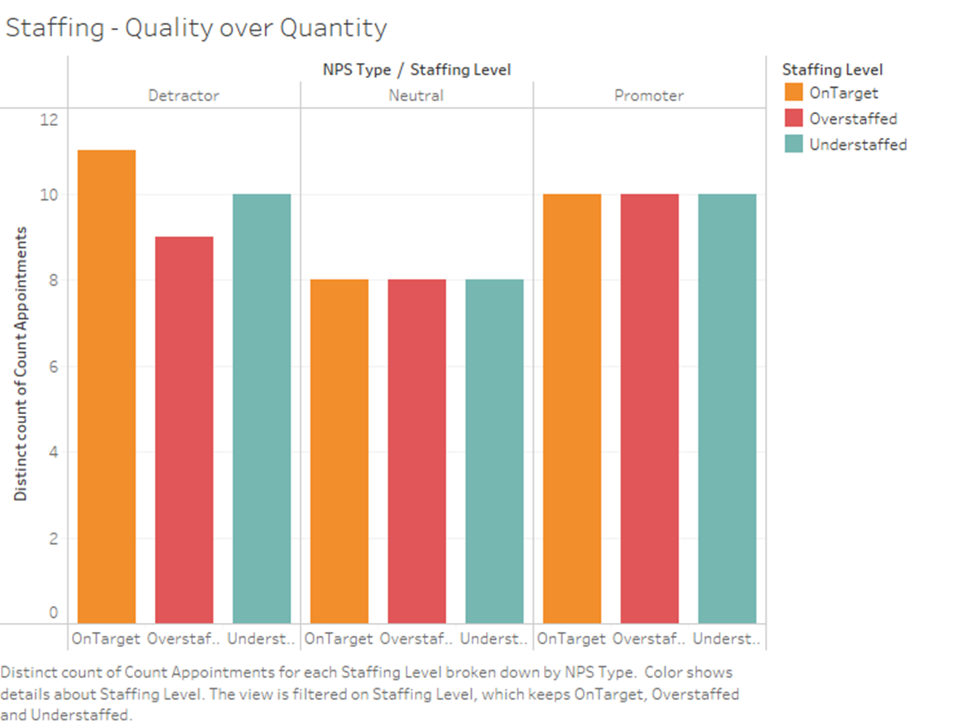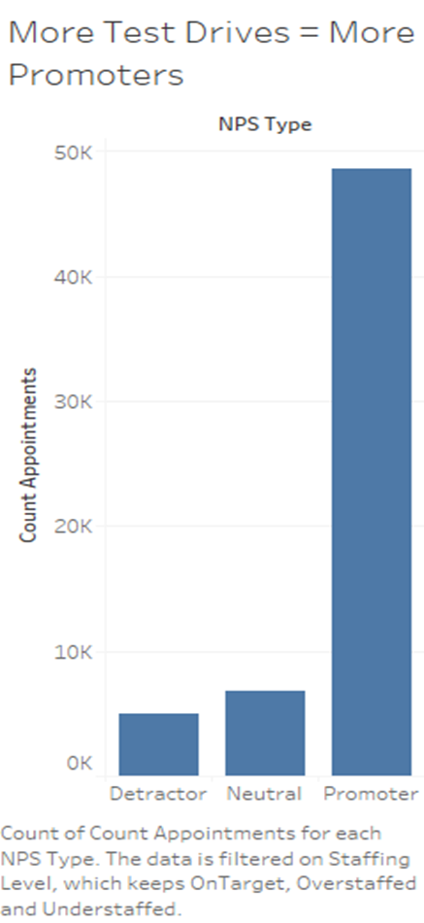

It would benefit CarMax to send someone to store 5694 to observe them, and potentially consider observing, relocating, or permanently closing the ill-performing stores. Our team believes it would be worthwhile to visit the store locations that had exceptional NPS scores, as well as the stores that had low scores in order to see what sets the best apart from the worst.